

**North South University**

# Department of Electrical & Computer Engineering

**LAB REPORT**

Course Code: EEE141L

Course Title: Electrical Circuits I Lab

Course Instructor: Dr. Mohammad Abdul Matin (Mtn)

Experiment Number: 5

Experiment Name:

|  |
| --- |
| Verification of Superposition Theorem |

Experiment Date: 1/4/2021

Date of Submission: 7/4/2021

Section: 3

Submitted To: Tabia Hossain

|  |  |
| --- | --- |
| Submitted By | Score |
| Student Name and ID:  1. Md. Rifat Ahmed - 1931725042 |  |

**Objectives:**

• To verify Superposition Theorem.

**List of Equipment:**

• OrCAD Software

• PSpice Simulation Software

• 1 × 3.3kΩ resistors

• 1 × 4.7kΩ resistor

• 1 × 1kΩ resistor

• Connecting wire

**Theory:**

**Superposition Theorem:**

If a circuit has two or more independent sources (voltage or current), then to determine the value of a specific variable, according to the superposition theorem we determine the contribution of each independent source to the variable and then add them up.

The main reason we use superposition theorem is because when we work with one independent source the circuit becomes much simpler and manageable and that way, we can get the values of a variable for each independent source much more easily and then just add them all to get the result.

We always need to remember two things while applying superposition theorem:

* We always consider one independent source for the circuit and turn rest of the sources off. For voltage sources we use a short circuit so that the voltage gets replaced with 0V and for current sources we use open circuit which replaces the current source with 0A value.
* Dependent sources are left intact as they are controlled by circuit variables.

**Application of Superposition Theorem:**

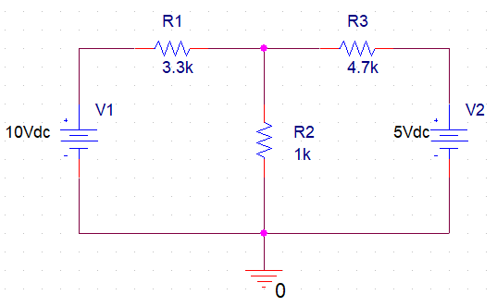

Figure – 1

So, if we have a circuit with more than one independent source like the one in figure – 1 and we want to find the value of the current going through the R2 resistor using superposition theorem then first we have to short the V2 voltage source in the circuit and calculate the current going through R2 and then again from the original circuit we have to short the V1 voltage source and this time we have to keep V2 voltage source alive and find the current going through R2.

After getting the values of the current going through R2 resistor for each voltage source we need to add them up and that’ll be the original amount of current going through the circuit with both V1 and V2 voltage source alive.

**Circuit Diagram:**



**Circuit – 1**

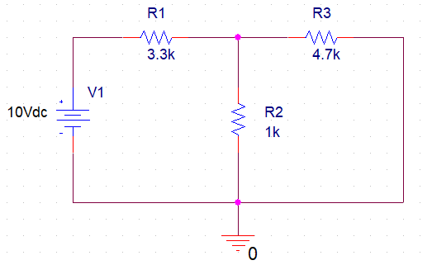

**Circuit – 2**

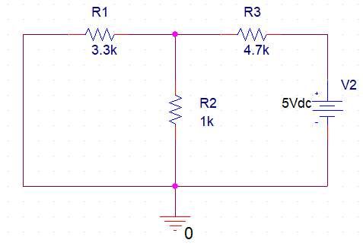

**Circuit – 3**

**Data, Readings and Results:**

**Table 1:**

|  |  |  |  |
| --- | --- | --- | --- |
| **I2** | **I’2** | **I’’2** | **I’2 + I’’2** |
| 2.701mA | 1.999mA | 0.702mA | 2.701mA |

**Table 2:**

|  |  |  |  |
| --- | --- | --- | --- |
| **VR1** | **V’R1** | **V’’R1** | **V’R1 + V’’R1** |
| 7.299V | 8.001V | -0.702V | 7.299V |

**Table 3:**

|  |  |  |  |
| --- | --- | --- | --- |
| **VR2** | **V’R2** | **V’’R2** | **V’R1 + V’’R2** |
| 2.701V | 1.999V | 0.702V | 2.701V |

**Table 4:**

|  |  |  |  |
| --- | --- | --- | --- |
| **VR3** | **V’R3** | **V’’R3** | **V’R3 + V’’R3** |
| -2.299V | 1.999V | -4.298V | -2.299V |

**Questions and Answers:**

**Answer of Question 1:**

If a circuit has two or more independent sources, then to determine the value of a specific variable, we determine the contribution of each independent source to the variable and then sum them up, this is called the superposition theorem.

**Answer of Question 2:**

Applying Mesh analysis on circuit – 1,

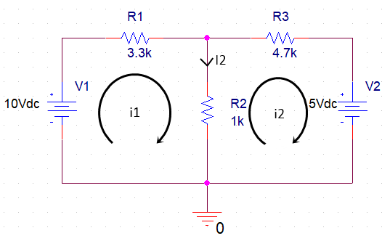

Applying KVL at loop 1,

–10 + 3.3 i1 + i1 – i2 = 0

=> 4.3 i1 – i2 = 10 ………… (1)

Applying KVL at loop 2,

i2 – i1 + 4.7 i2 + 5 = 0

=> – i1 + 5.7 i2 = – 5

=> 5.7 i2 = i1 – 5

=> i2 = ………… (2)

From (1),

4.3 i1 – = 10

=> 24.51 i1 – i­1 + 5 = 57

=> 23.51 i1 = 52

؞ i1 = 2.212 mA

From (2),

i2 = = – 0.489 mA

؞ I2 = i1 - i2 = 2.212 – (– 0.489) = 2.701 mA

VR1 = i1 × R1 = 2.212 × 3.3 = 7.300 V

VR2 = I2 × R2 = 2.701 × 1 = 2.701 V

VR3 = i2 × R3 = – 0.489 × 4.7 = – 2.298 V

Now, Applying Superposition theorem to calculate all the other values of the tables,

Given,

V1 = 10V

V2 = 5V

R1 = 3.3kΩ

R2 = 1kΩ

R3 = 4.7kΩ

For 10V source,

RT = R1 + (R2||R3)

= R1 +

= 3.3 +

= 4.125 kΩ

؞ IT = = 2.424 mA

؞ I’2 = × IT = × 2.424 = 1.999 mA

؞V’R1 = × R1

= × 3.3

= 8.000 V

؞V’R2 = V’R3 = × (R2||R3)

= ×

= 1.999 V

For 5V source,

RT = (R1||R2) + R3

= + R3

= + 4.7

= 5.467 kΩ

؞ IT = = 0.915 mA

؞ I’’2 = × IT = × 0.915 = 0.702 mA

In Circuit – 3, the current flows through R1 resistor from negative polarity to positive polarity,

؞V’’R1 = – ( × (R1||R2))

= – ( × )

= – 0.702 V

؞V’’R2 = × (R1||R2)

= ×

= 0.702 V

Again, in R3 resistor the current flows from negative polarity to positive polarity,

؞V’’R3 = – ( × R3)

= – ( × 4.7)

= – 4.299 V

؞ According to superposition theorem,

I2 = I’2 + I’’2 = 1.999 + 0.702 = 2.701 mA

VR1 = V’R1 + V’’R1 = 8.000 – 0.702 = 7.298 V

VR2 = V’R2 + V’’R2 = 1.999 + 0.702 = 2.701 V

VR3 = V’R3 + V’’R3 = 1.999 – 4.299 = –2.300V

**Answer of Question 3:**

From the Tables we can get the measured data,

I2 = 2.701 mA

I’2 + I’’2 = 2.701 mA

VR1 = 7.299 V

V’R1 + V’’R1 = 7.299 V

VR2 = 2.701 V

V’R2 + V’’R2 = 2.701 V

VR3 = –2.299V

V’R3 + V’’R3 = –2.299V

Here, if we take a look at the values of each variable for all the independent sources and the summation of the contribution of each source, they’re both the same.

For example, the value of I2 for all the sources is 2.701mA but the summation of contribution of each source (I’2 + I’’2) is also 2.701mA. And it’s the same way for VR1, VR2 and VR3 as well. So according to these measured data we can say that our circuit follows superposition theorem.

**Answer of Question 4:**

We know,

The formula to calculate % error = $|\frac{Experimental value - Theoretical value }{Theoretical value }|$ × 100%

؞ % Error for I2 = × 100% = 0%

؞ % Error for I’2 = × 100% = 0%

؞ % Error for I’’2 = × 100% = 0%

؞ % Error for (I’2 + I’’2) = × 100% = 0%

؞ % Error for VR1 = × 100% = 0.01%

؞ % Error for V’R1 = × 100% = 0.01%

؞ % Error for V’’R1 = × 100% = 0%

؞ % Error for (V’R1 + V’’R1) = × 100% = 0.01%

؞ % Error for VR2 = × 100% = 0%

؞ % Error for V’R2 = × 100% = 0%

؞ % Error for V’’R2 = × 100% = 0%

؞ % Error for (V’R2 + V’’R2) = × 100% = 0%

؞ % Error for VR3 = × 100% = 0.04%

؞ % Error for V’R3 = × 100% = 0%

؞ % Error for V’’R3 = × 100% = 0.02%

؞ % Error for (V’R3 + V’’R3) = × 100% = 0.04%

**Discussion:**

From this experiment we’ve learned what superposition theorem is and how to apply that. When a circuit has multiple independent sources it’s not easy to find the value of a variable however normally we could find those values using mesh or nodal analysis and like those analysis we can also use the superposition theorem for the same purpose. However, to apply superposition theorem we need to consider one source at a time and calculate the value of the variable that we need for each individual source and then finally sum the values for each source and that’s our result. Now coming to the result of our experiment, the percentage of error is very low, zero for some and close to zero for some variables, which indicates that our superposition theorem application was a success. And no during this experiment we didn’t face any problem as everything was crystal clear and understandable during the class.